Modeling Digital Storage Data Degradation Using a System of Ordinary Differential Equations

Project 4 – Degradation of Data Integrity
CST-305: Principles of Modeling and Simulation Design
Jordan Cruze
Dr. Citro
10/25/2026

GitHub Link: https://github.com/Jordan-Cruze/CST-305

Team Responsibilities
Team Member | Responsibilities
Jordan Cruze | Research and identification of digital storage degradation factors; mathematical derivation of the system of ordinary differential equations; selection of model parameters and initial conditions; Python implementation and numerical solution; data visualization; testing and troubleshooting; and project documentation.

- System Performance Context
Digital storage systems are designed to preserve information so that it can be retrieved accurately at a later time. Although digital information is represented using discrete binary values, stored data can be affected by multiple sources of degradation. These may include bit errors, electrical disturbances, repeated writing or updating, physical deterioration of storage media, and failures in backup or recovery processes.
For this project, a digital image is used as the example of stored data. The image represents information that has been stored in a digital storage system and is subject to degradation over time. Rather than modeling a particular physical storage device, the project uses a mathematical model to represent how several independent degradation factors can contribute to an overall reduction in data integrity.
The model uses five degradation factors:
- Bit-flip errors – represent unintended changes to stored binary information.
- Electrical/storage errors – represent errors caused by electrical disturbances or storage-related instability.
- Write/update degradation – represents corruption associated with repeated writing or updating of stored information.
- Physical media degradation – represents deterioration of the physical medium storing the data.
- Backup/recovery errors – represent errors introduced when recovering or restoring information from a backup.
Each factor is assigned a different degradation rate because the factors do not necessarily affect stored information at the same rate.
- Specific Problem Solved
The problem addressed by this project is determining how the integrity of stored digital data changes over time when multiple sources of degradation are present. A single degradation factor would not adequately represent the complexity of a digital storage system because different sources of corruption can affect stored information at different rates.
The project therefore models five degradation factors simultaneously using a system of ordinary differential equations. Each variable represents the accumulated degradation associated with one factor. The individual factors are then combined using weighted contributions to calculate an overall degradation value.
The resulting model provides two forms of output. First, numerical and graphical results show how each degradation factor changes over the simulated storage period. Second, the model is applied to a sample raccoon image to provide a visual representation of progressively decreasing data quality. The image visualization is intended to demonstrate the meaning of the mathematical model rather than simulate the exact behavior of a particular storage device.
- Mathematical Approach
Mathematical Model
A system of ordinary differential equations can be represented in matrix form as:
$$x^{'}\left(t\right)=Ax\left(t\right)+f$$
where $x(t)$ is the vector containing the unknown degradation variables, $A$ is the coefficient matrix, and $f$ is the forcing vector.
For this project, five variables are used:
$$x\left(t\right)=\left[\begin{aligned}x_{1}\left(t\right) \\ x_{2}\left(t\right) \\ x_{3}\left(t\right) \\ x_{4}\left(t\right) \\ x_{5}(t)\end{aligned}\right]$$
where:
- $x_{1}$ = bit-flip degradation
- $x_{2}$ = electrical/storage degradation
- $x_{3}$ = write/update degradation
- $x_{4}$ = physical media degradation
- $x_{5}$ = backup/recovery degradation

The implemented system is:
$$x_{1}^{'}=-0.010x_{1}+0.010$$
$$x_{2}^{'}=-0.015x_{2}+0.015$$
$$x_{3}^{'}=-0.020x_{3}+0.020$$
$$x_{4}^{'}=-0.008x_{4}+0.008$$
$$x_{5}^{'}=-0.012x_{5}+0.012$$
These equations can be written as:
$$x\left(t\right)=\left[\begin{aligned}x_{1}^{'}\left(t\right) \\ x_{2}^{'}\left(t\right) \\ x_{3}^{'}\left(t\right) \\ x_{4}^{'}\left(t\right) \\ x_{5}^{'}(t)\end{aligned}\right]=\left[\begin{matrix}-0.010 & 0 & 0 & 0 & 0 \\ 0 & -0.015 & 0 & 0 & 0 \\ 0 & 0 & -0.020 & 0 & 0 \\ 0 & 0 & 0 & -0.008 & 0 \\ 0 & 0 & 0 & 0 & -0.012\end{matrix}\right]\left[\begin{aligned}x_{1}\left(t\right) \\ x_{2}\left(t\right) \\ x_{3}\left(t\right) \\ x_{4}\left(t\right) \\ x_{5}(t)\end{aligned}\right]+\left[\begin{aligned}0.010 \\ 0.015 \\ 0.020 \\ 0.008 \\ 0.012\end{aligned}\right]$$
The default initial conditions are:
$$x_{1}\left(0\right)=x_{2}\left(0\right)=x_{3}\left(0\right)=x_{4}\left(0\right)=x_{5}\left(0\right)=0$$
This represents a hypothetical newly stored image with no accumulated degradation at the beginning of the simulation.
Overall Degradation
Because the five factors do not contribute equally, weighted coefficients are used:
$$w=\left[\begin{matrix}0.30, & 0.15, & 0.20, & 0.25, & 0.10\end{matrix}\right]$$
The weights sum to one:
$$0.30+0.15+0.20+0.25+0.10=1$$
The overall degradation is calculated as:
$$D\left(t\right)=0.30x_{1}\left(t\right)+0.15x_{2}\left(t\right)+0.20x_{3}\left(t\right)+0.25x_{4}\left(t\right)+0.10x_{5}\left(t\right)$$
The remaining data quality is then:
$$Q\left(t\right)=1-D(t)$$
and is displayed as a percentage:
$$Q_{\%}\left(t\right)=100(1-D\left(t\right))$$
This allows the simulation to represent both the amount of degradation and the percentage of data quality remaining.
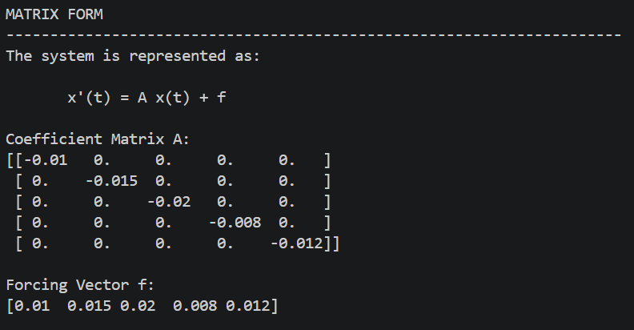
Figure 1. Matrix representation of the digital storage degradation ODE system.
- Implementation Approach
The simulation was implemented in Python using NumPy, SciPy, SymPy, Matplotlib, and Pillow.
SymPy is used to parse the ODE equations and convert them into a numerical coefficient matrix and forcing vector. This allows the program to accept either the predefined equations or equations entered by the user.
NumPy is used for numerical arrays, matrix operations, and calculation of the weighted overall degradation.
SciPy provides the solve_ivp function used to numerically solve the system of ordinary differential equations. The RK45 method is used to calculate the solution over the specified simulation period.
Matplotlib is used to visualize the individual degradation factors, overall degradation, and remaining data quality.
Pillow is used to load the sample raccoon image and create visual representations of increasing data degradation.
The default simulation uses a duration of 100 years and 500 time points. The numerical solution is used to calculate the five individual degradation values at each time point. These values are then combined using the predefined weights to calculate overall degradation and remaining data quality.
The image visualization uses the calculated degradation values to add increasing levels of Gaussian noise to the original image. This creates a visual representation of progressively corrupted data.
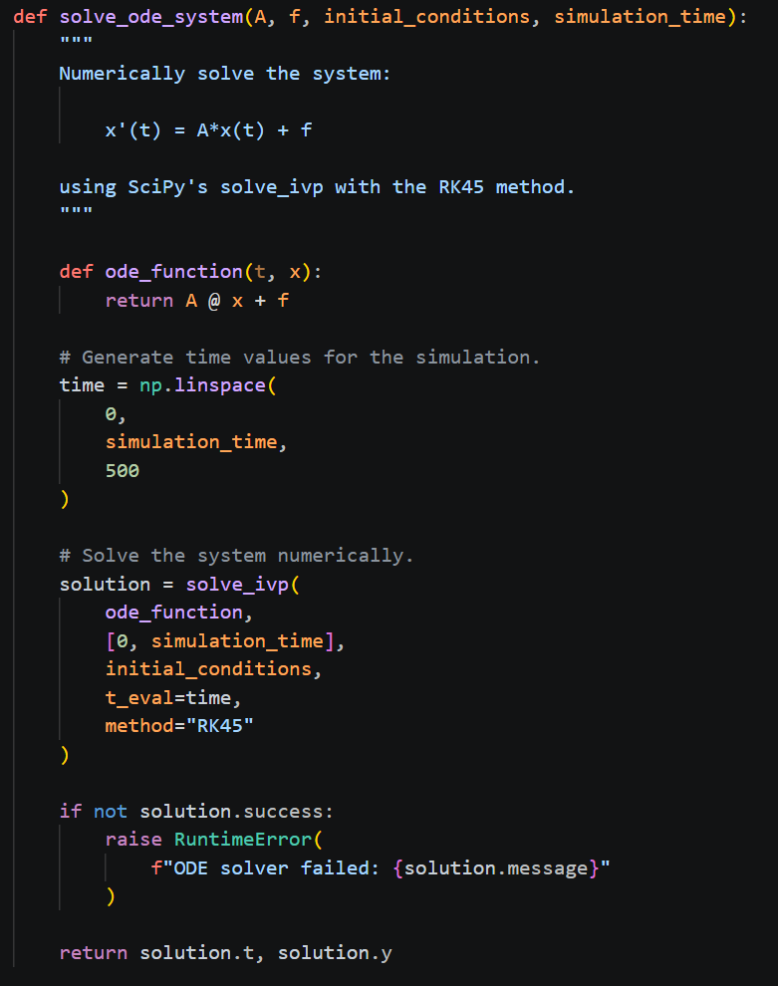
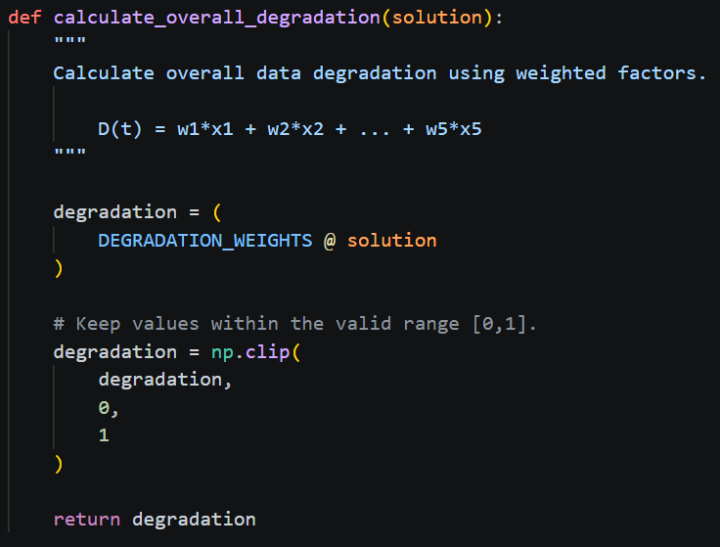
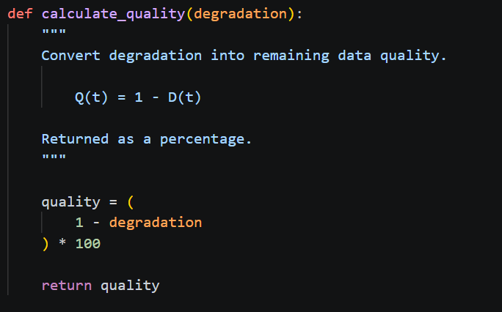
Figure 2. Python implementation of the ODE solver and overall data-quality calculations.

- Algorithm and Flowchart
Algorithm
- Start the program.
- Display the digital storage degradation model information.
- Load the default ODE system or accept user-defined equations.
- Parse the equations using SymPy.
- Convert the equations into matrix form \(x'=Ax+f\).
- Obtain the initial conditions.
- Obtain the simulation duration.
- Solve the ODE system using SciPy's RK45 solver.
- Calculate the weighted overall degradation.
- Calculate remaining data quality.
- Display the individual degradation factors.
- Display overall degradation and data quality.
- Load sample_image.jpg.
- Generate progressively degraded versions of the image.
- Display the image progression.
- Optionally save the degraded images.
- Display the final simulation results.
- End the program.

Flowchart

Figure 3. Algorithm flowchart for the digital storage degradation simulation.

- Results and Visualizations
Results
The simulation demonstrates that the individual degradation factors increase over time, while the remaining data quality decreases. Because each factor has a different rate coefficient and weight, the factors do not contribute equally to the overall degradation.
The default 100-year simulation begins with zero degradation and therefore 100% data quality. As time increases, each degradation factor approaches a limiting value. The weighted combination of these factors produces an overall degradation curve, while the calculated data quality decreases correspondingly.
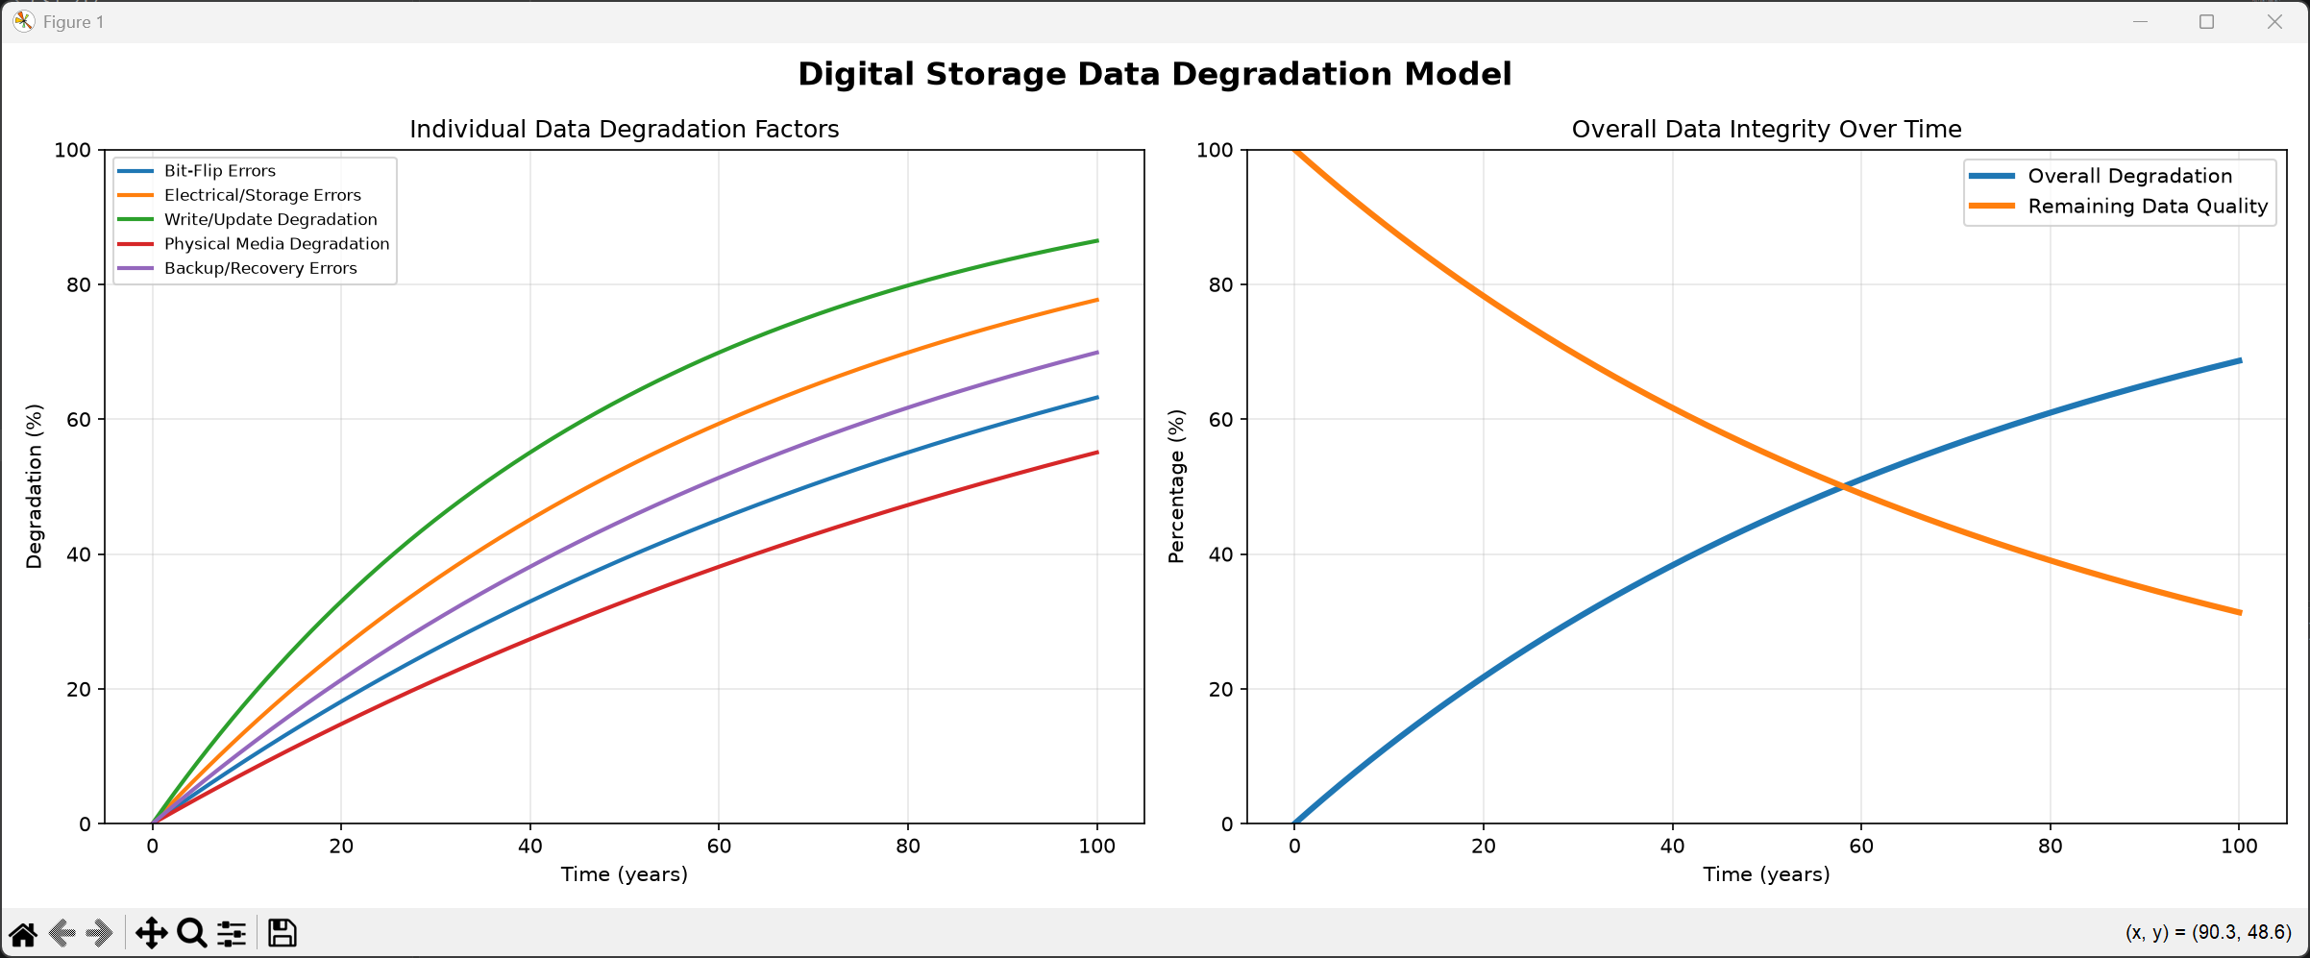
Figure 4. Individual degradation factors and overall data quality over the 100-year simulation.
The first chart shows that all five degradation factors increase over time, although they do so at different rates. The second chart combines these factors using their assigned weights and shows the resulting decrease in remaining data quality. This demonstrates how multiple degradation mechanisms can be represented simultaneously using a system of ODEs.
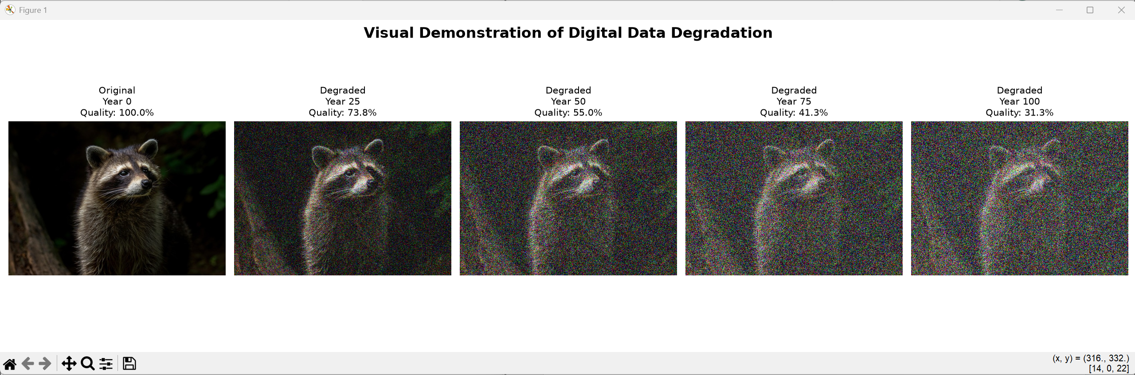
Figure 5. Visual representation of progressive digital image degradation over time.
The image progression provides a visual interpretation of the mathematical model. The original image represents the initial condition with no degradation. Subsequent versions use the degradation values calculated by the ODE system to introduce progressively greater visual corruption. The image does not represent the exact physical behavior of a particular storage medium; instead, it provides an intuitive visualization of the decreasing data quality predicted by the model.
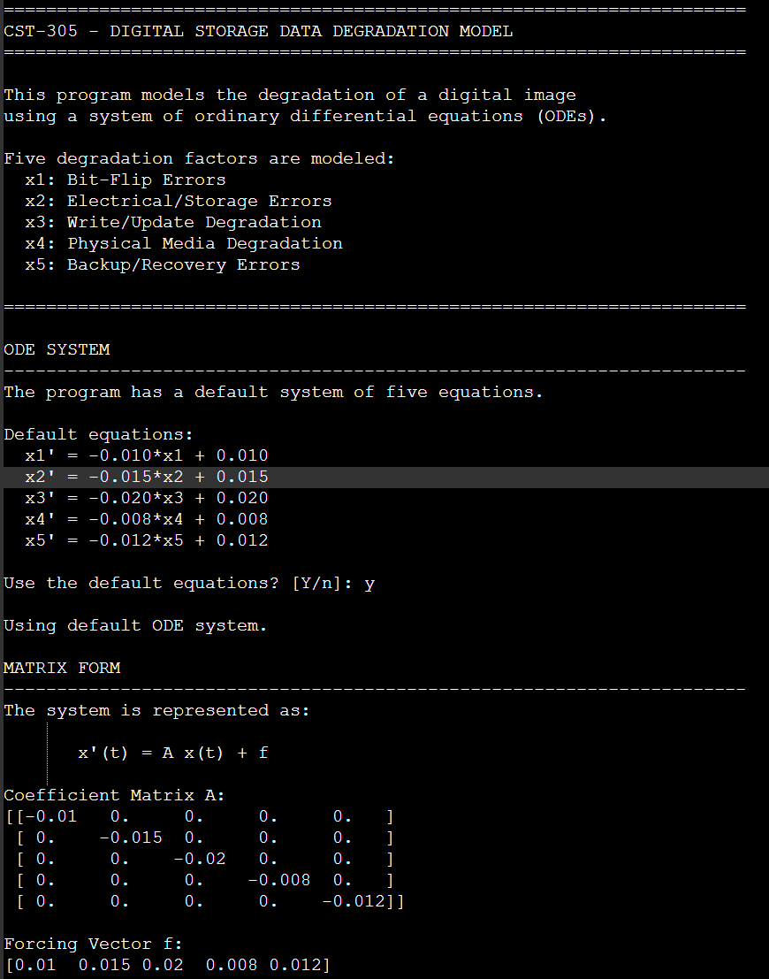
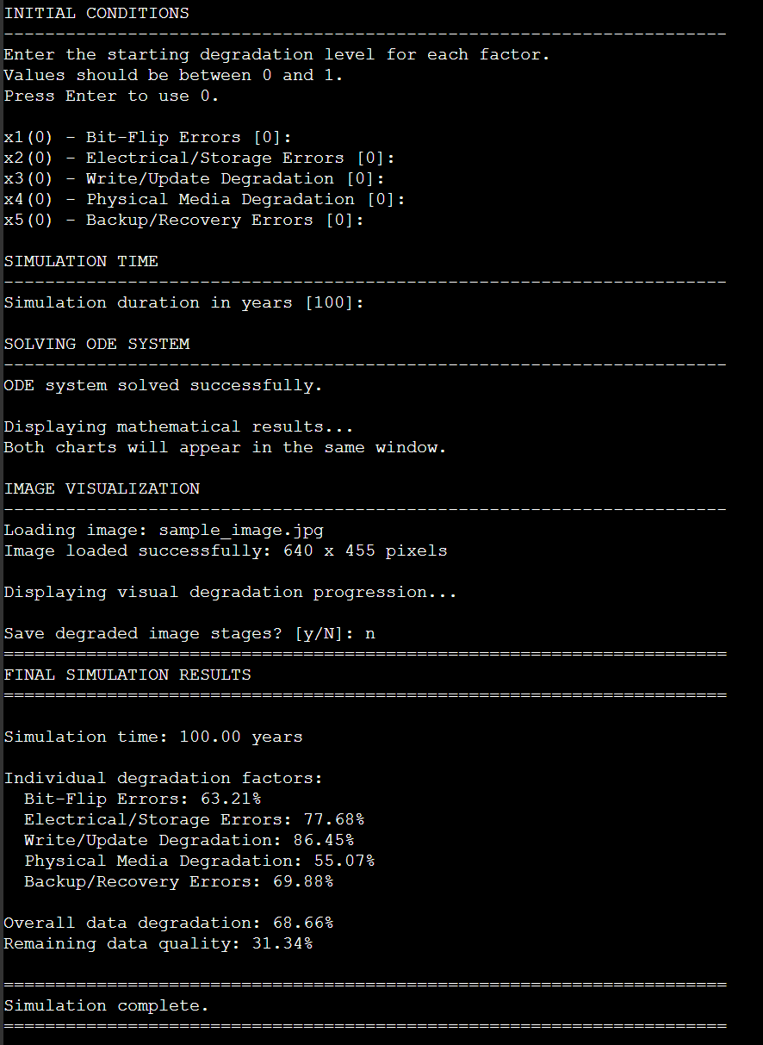
Figure 6. Final numerical results from the digital storage degradation simulation.
- Conclusion
The digital storage degradation model demonstrates how a system of ordinary differential equations can be used to represent the gradual loss of data integrity over time. Five separate degradation factors were modeled, each with a different rate of change. These factors were combined using weighted contributions to produce an overall degradation measurement and corresponding data-quality percentage.
The numerical solution demonstrates that the individual degradation factors increase at different rates, resulting in a gradual reduction in overall data quality. The accompanying image visualization provides an intuitive representation of this process by showing progressively corrupted versions of the same stored image.
Although the model does not represent the exact physical failure characteristics of a specific storage technology, it provides a mathematical framework for studying how multiple sources of degradation can affect stored digital information. The project also demonstrates how Python-based numerical methods can be combined with visualization techniques to make a system of ODEs more understandable and applicable to a real-world computing problem.

References
Dormand, J. R., & Prince, P. J. (1980). A family of embedded Runge-Kutta formulae. Journal of Computational and Applied Mathematics, 6(1), 19–26. https://doi.org/10.1016/0771-050X(80)90013-3
Kissel, R. L., Scholl, M. A., Skolochenko, S., & Li, X. (2006). Guidelines for media sanitization (NIST Special Publication 800-88). National Institute of Standards and Technology. https://doi.org/10.6028/NIST.SP.800-88
Matplotlib Development Team. (n.d.). Matplotlib documentation. https://matplotlib.org/stable/
NumPy Developers. (n.d.). NumPy documentation. https://numpy.org/doc/
Pillow Contributors. (n.d.). Pillow documentation. https://pillow.readthedocs.io/en/stable/
SciPy Developers. (n.d.). solve_ivp. SciPy documentation. https://docs.scipy.org/doc/scipy/reference/generated/scipy.integrate.solve_ivp.html
SymPy Development Team. (n.d.). SymPy documentation. https://docs.sympy.org/

